Launch Temlpate.
Content:
- AMI and Launch template Concepts
- Creating Launch Template
- Manually Replicating and deploying an existing server using L.T

1.AMI and Launch template Concepts :
We can totally replicate an existing server using Launch Template .
Instance -> AMI -> Launch Template -> replica of instance [Manual deployment ]
Instance -> AMI ->Launch Template-> (ASG - >)- >replica of instance [Manual deployment ]
Requirement –
AMI, Launch Template.
2 .Creating Launch Template: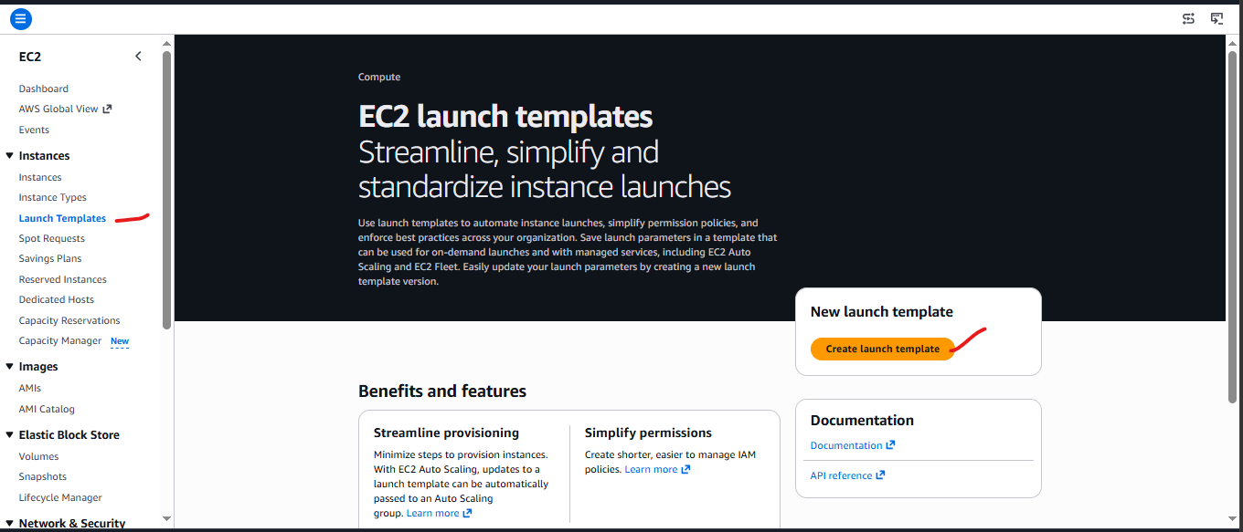 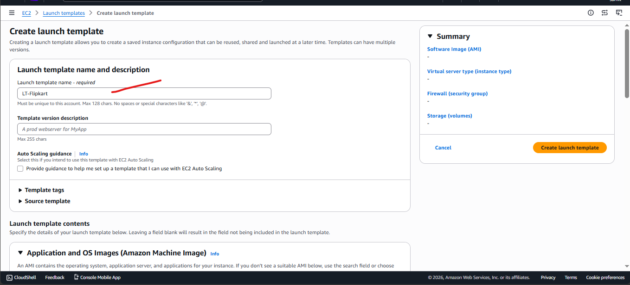

Select the AMI that you have created for Server / application configuration.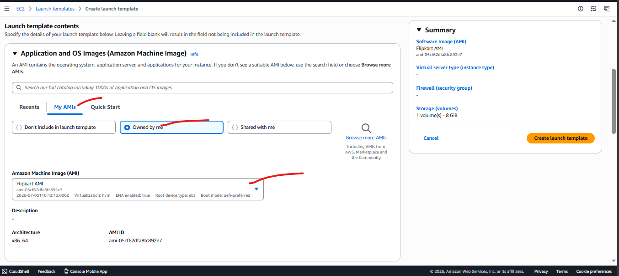

Give same instance type and Private key . Later we can change
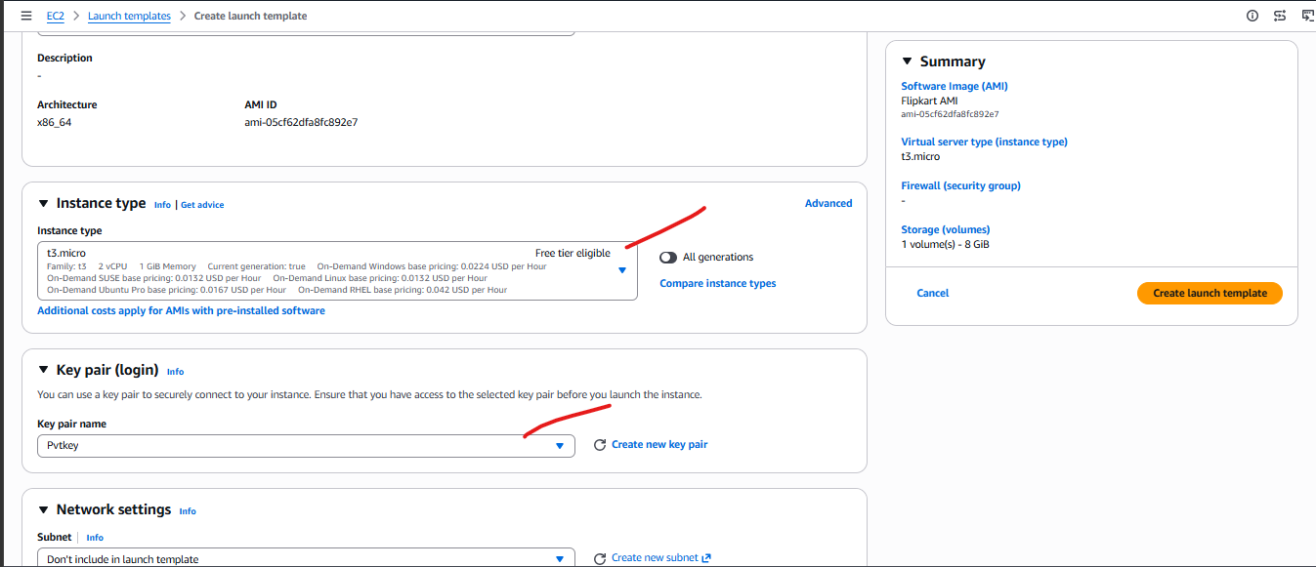

Select subnet , SGs . Even if you are selecting Subnet it will ask about subnet by ASG during automation
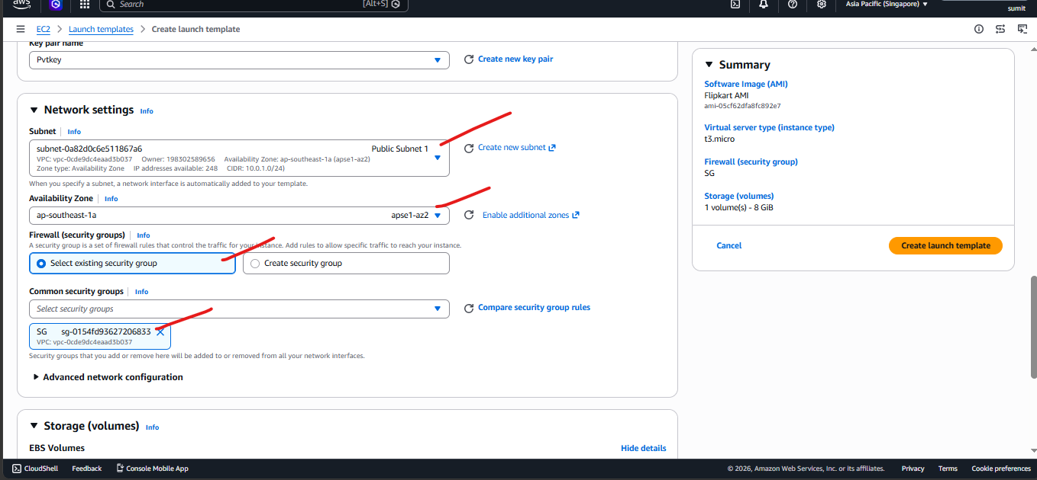
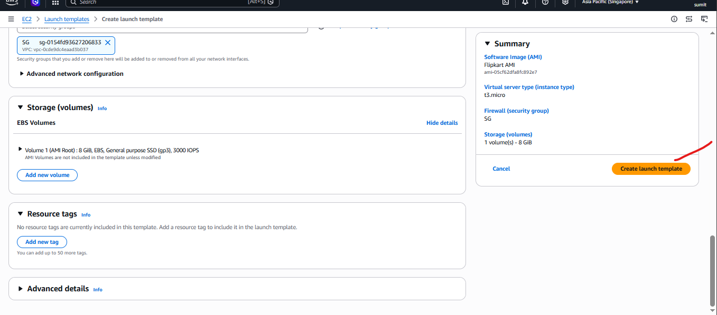
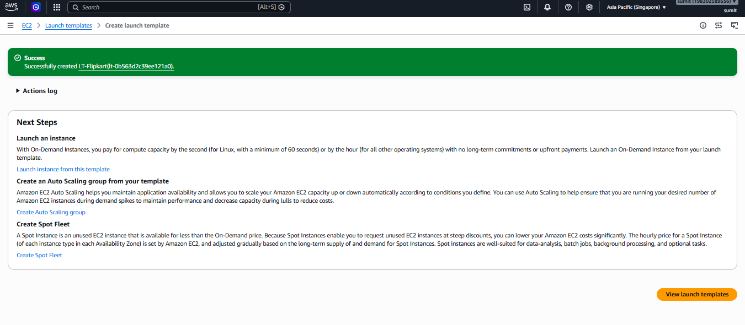
Finally a Launch template created
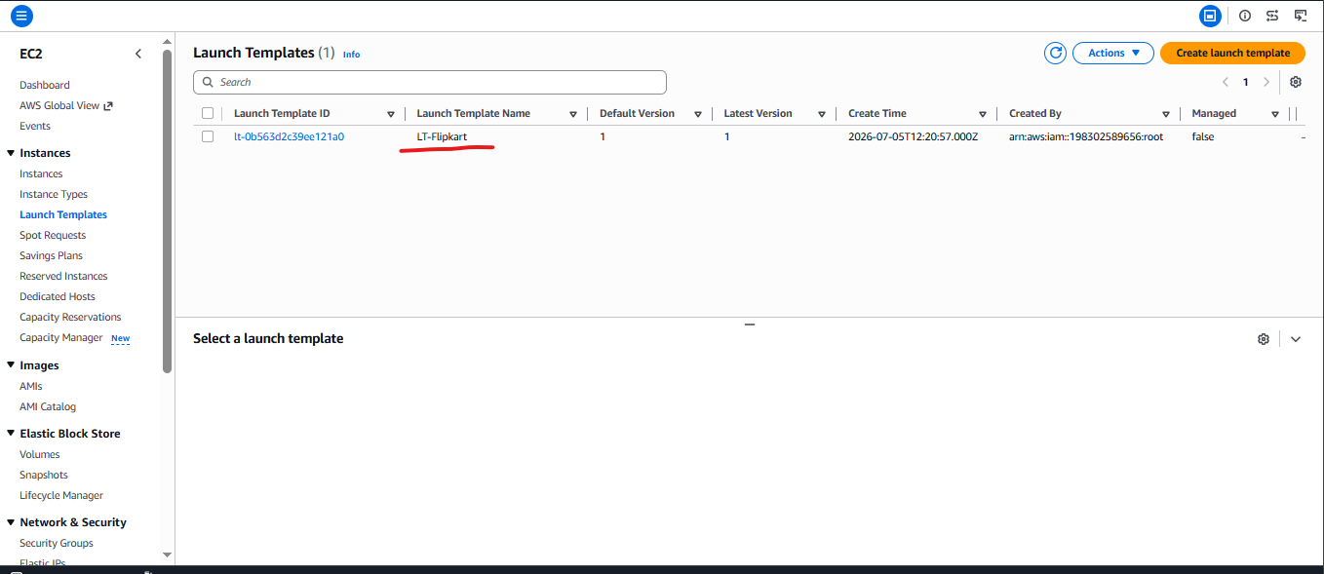

3.Manually Replicating and deploying an existing server using L.T
Instances > Launch template >select desired LT > actions > Launch Instance from Template
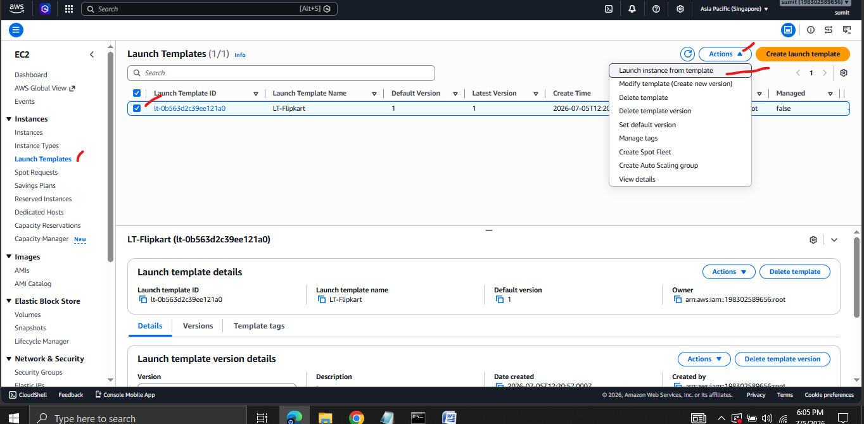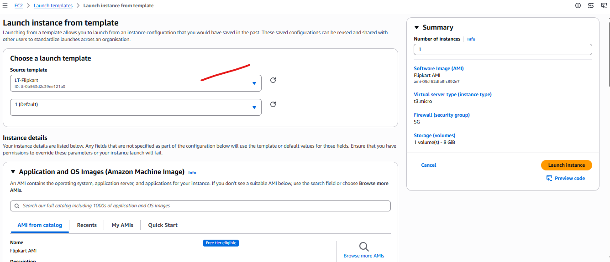

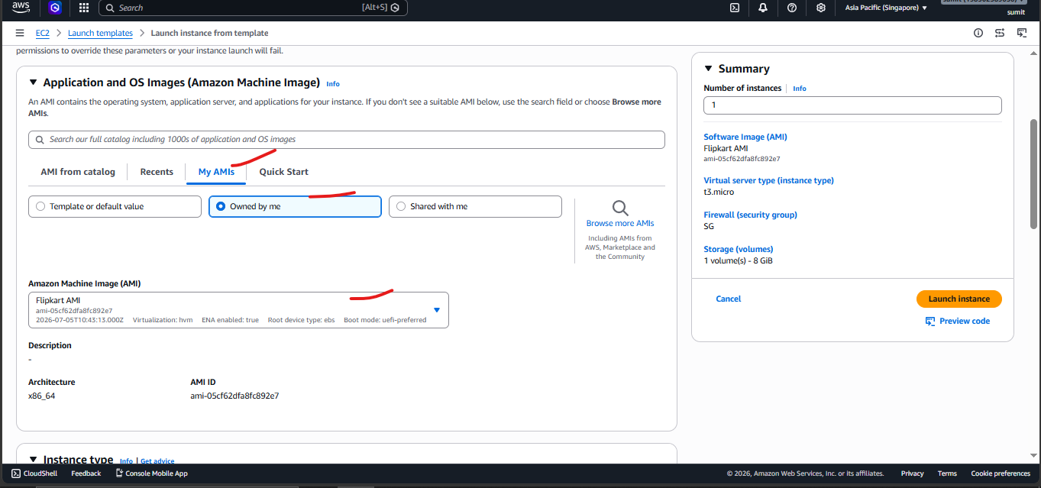

Select default or modify as required
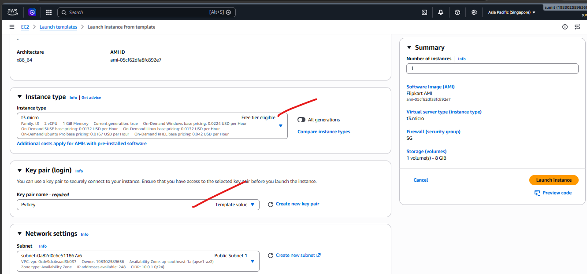

As you can see even if we have selected Template deployment subnet still it allows us to change it .
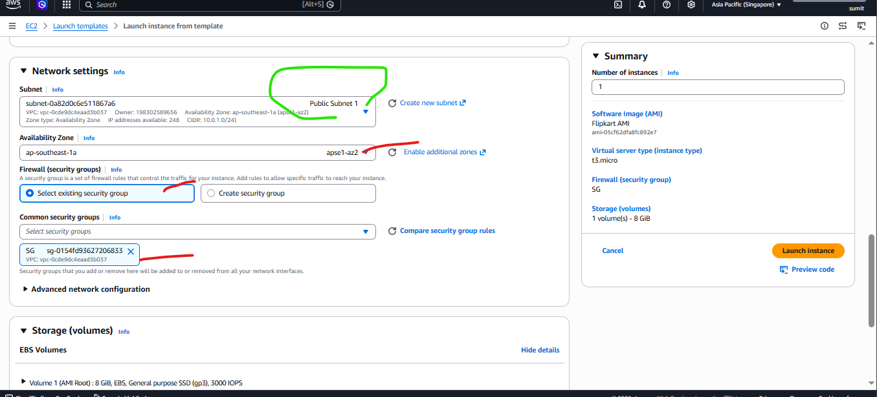
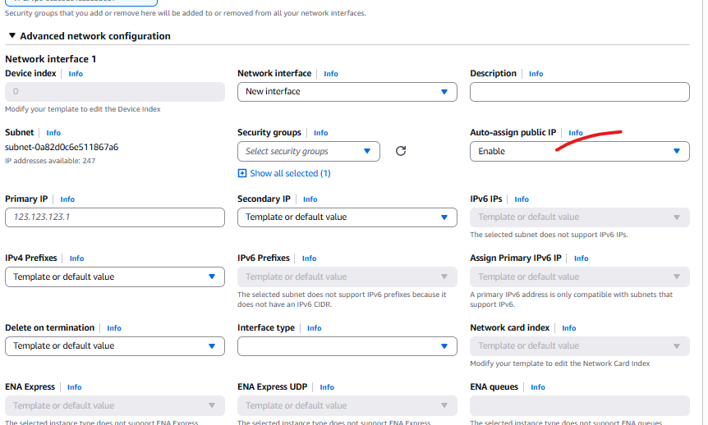
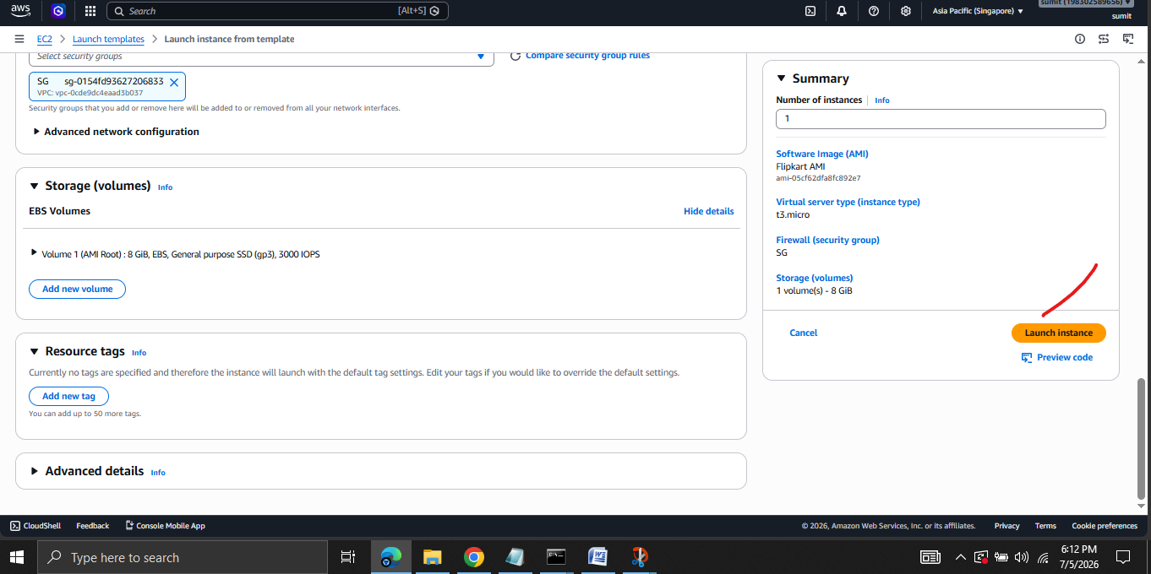
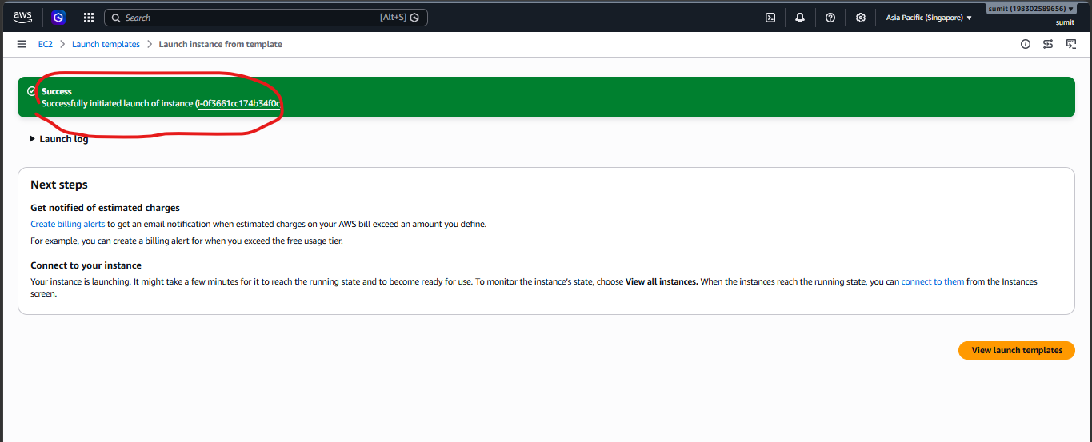

Now you can see a duplicate instance is created using LT.
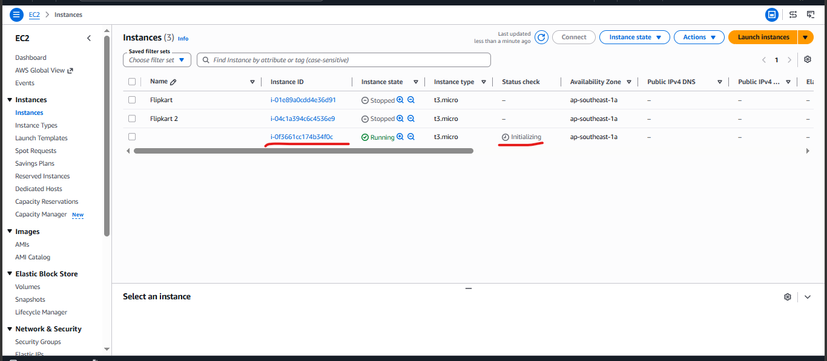
I renamed it as Flipkart –LT
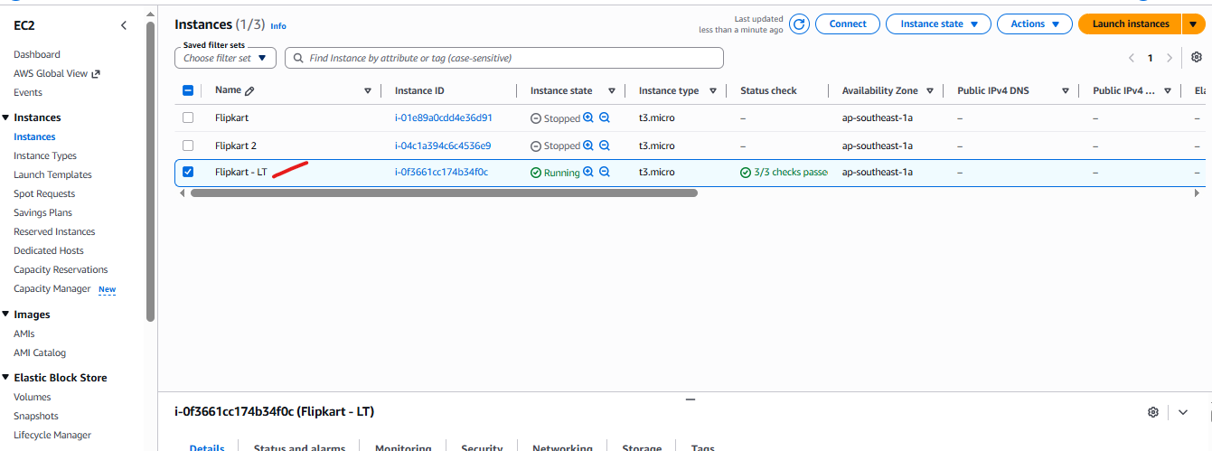

Now using the Public ip try to access the server , you can see the nginx home page will pop up ,it means the original Flipkart server successfully replicated using LT .
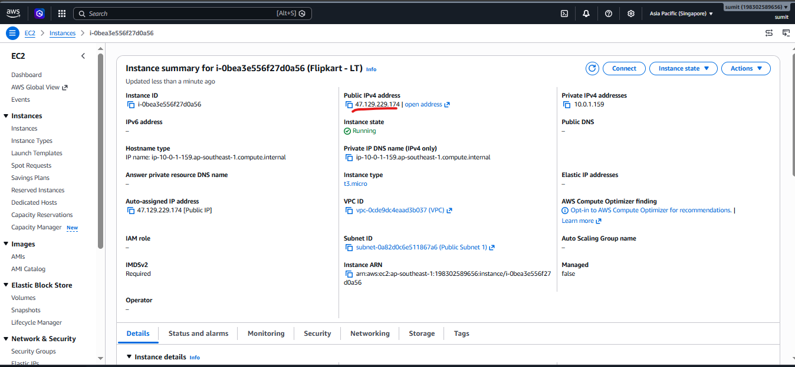

The replicated server Flipkart –LT already running nginx server . Cause the original server from which AMI created , had been running the nginx server .
